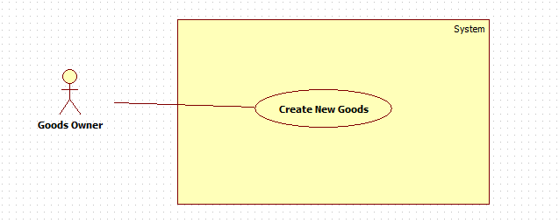

|  |  |  |  |
| --- | --- | --- | --- |
| **USE CASE – CPS001** | | | |
| **Use Case No.** |  | **Use Case Version** | 2.0 |
| **Use Case Name** | Create New Goods | | |
| **Author** | ThinhDP | | |
| **Date** |  | **Priority** | High |
| **Actor:** Goods owner  **Summary:** This use case allows goods owner to post new goods.  **Goal:** Add new goods to database  **Triggers:** Goods owner click on “Đăng hàng” button in action bar.  **Preconditions:**   * User must log in to the system with role goods owners.   **Post Conditions:**   * **Success:** New goods will be added to database. Success message will be shown. * **Fail:** Goods will not be added. Error message will be shown.   **Main Success Scenario:**   |  |  |  | | --- | --- | --- | | Step | Actor Action | System Respone | | 1 | Goods owner clicks “Đăng hàng” button. | System navigates to “Tạo hàng” page.   * Loại hàng: drop down list, required, (Thức ăn, Nội thất, Gia dụng, Vật liệu). * Khối lượng: textbox, min length: 1, max length: 5, min value: 1, max value: 90000, required. * Ngày gửi hàng: datepicker, date range: current date to current date + 1 month, required. * Thời gian gửi hang: timepicker, min time: current time + 6 hour, required * Ngày giao hàng: datepicker, date range: current date to current date + 1 month, required * Thời gian giao hàng: timepicker, required. * Địa điểm nhận hàng: textbox, min length: 1, max length: 100, required. * Địa điểm giao hàng: textbox, min length: 1, max length: 100, required. * Ghi chú: textbox, min length: 1, max length: 250, not required * Giá tiền: textbox, min length:1, max length: 10, required * Tạo hàng: button | | 2 | Input field.  [Alternative 1,2] |  | | 3 | Click on “Tạo hàng” button | New goods will be added to database and show “Bạn đã thêm hàng thành công”.  [Exception 1,2,3,4,5,6,7,8,9,10,11,12,13] |   **Alternative Scenario:**   |  |  |  | | --- | --- | --- | | Step | Actor Action | System Respone | | 1 | Goods owner clicks on Map ImageButton next to“Địa điểm nhận hàng” | System navigates to “Địa điểm” page:   * Google map * Đồng ý: button | | 2 | Owner drags marker to appropriate position | System will update new marker’s latitude and longitude | | 3 | Click on “Đồng ý” | Marker position will be saved to database, | | Step | Actor Action | System Respone | | 1 | Goods owner clicks on Map ImageButton next to“Địa điểm giao hàng” | System navigates to “Địa điểm” page:   * Google map * Đồng ý: button | | 2 | Owner drags marker to appropriate position | System will update new marker’s latitude and longitude | | 3 | Click on “Đồng ý” | Marker position will be saved to database, |   **Exceptions:**   |  |  |  | | --- | --- | --- | | No | Actor Action | System Response | | 1 | Click on “Tạo hàng” button | “Khối lượng” is empty or longer than 5 words. Show error message: “Khối lượng giới hạn từ 1 đến 5 ký tự”. | | 2 | Click on “Tạo hàng” button | “Ngày gửi hàng” is empty. Show error message: “Vui lòng chọn ngày gửi hàng”. | | 3 | Click on “Tạo hàng” button | “Thời gian gửi hàng” is empty. Show error message: “Vui lòng chọn giờ gửi hàng”. | | 4 | Click on “Tạo hàng” button | “Ngày giao hàng” is empty. Show error message: “Vui lòng chọn ngày giao hàng”. | | 5 | Click on “Tạo hàng” button | “Thời gian giao hàng” is empty. Show error message: “Vui lòng chọn giờ giao hàng”. | | 6 | Click on “Tạo hàng” button | “Địa điểm nhận hàng” is empty or longer than 100 words. Show error message: “Địa điểm nhận hàng giới hạn từ 1 đến 100 ký tự”. | | 7 | Click on “Tạo hàng” button | “Địa điểm giao hàng” is empty or longer than 100 words. Show error message: “Địa điểm giao hàng giới hạn từ 1 đến 100 ký tự”. | | 8 | Click on “Tạo hàng” button | “Giá tiền” is empty or longer than 10 words. Show error message: “Giá tiền giới hạn từ 1 đến 10 ký tự”. | | 9 | Click on “Tạo hàng” button | “Khối lượng” value is smaller than 1 and bigger than 90000. Show error message: “Khối lượng giới hạn từ 1 đến 90000 kg”. | | 10 | Click on “Tạo hàng” button | “Ngày giao hàng” is earlier than “Ngày gửi hàng”. Show error message: “Ngày gửi hàng phải sớm hơn ngày gửi hàng”. | | 11 | Click on “Tạo hàng” button | If “Ngày gửi hàng” is current date and “Thời gian gửi hàng” is not later than current time 6 hours. Show error message: “Thời gian gửi hàng phải trễ hơn hiện giờ 6 tiếng“ | | 12 | Click on “Tạo hàng” button | If “Ngày nhận hàng” is the same as “Ngày giao hàng” and “Thời gian giao hàng” is not later than “Thời gian nhận hàng” 15 hours. Show error message: “Vui lòng chọn thời gian giao hàng trễ hơn thời gian gửi hàng 15 tiếng”. | | 13 | Click on “Tạo hàng” button | “Ghi chú” is empty or longer than 250 words. Show error message: “Ghi chú chỉ có giới hạn từ 1 đến 250 ký tự”. |   **Relationships:** N/A  **Business Rules:**   * Goods is added to database with status “1”. * System will notified owner if the goods is added successfully or not. * Delivery date must be later than pickup date. If pickup date is current date, pickup time must be later than current time 6 hours. If delivery date is pickup date, delivery time must be later than pickup time 15 hours. * “Khối lượng” is weighted by kg and limited from 1 to 90000. * “Giá tiền” is calculated by thousand. * Owner can edit marker if marker is not correct. If owner does not edit marker, the address that owner input will be used as marker. | | | |

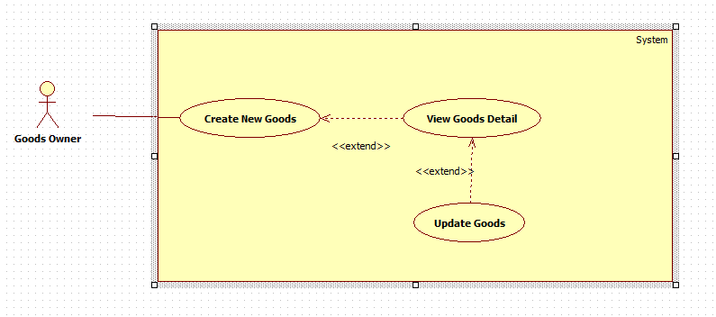

|  |  |  |  |
| --- | --- | --- | --- |
| **USE CASE – CPS001** | | | |
| **Use Case No.** |  | **Use Case Version** | 2.0 |
| **Use Case Name** | Update Goods | | |
| **Author** | ThinhDP | | |
| **Date** |  | **Priority** | High |
| **Actor:** Goods owner  **Summary:** This use case allows goods owner to update existed goods  **Goal:** Update existed goods  **Triggers:** Goods owner click on a goods in “Hàng hóa” tab  **Preconditions:**   * Goods exists in database. * User must log in to the system with role goods owners. * Goods is not in deal.   **Post Conditions:**   * **Success:** Goods will be updated with new information * **Fail:** Goods will not be updated. Error message will be shown.   **Main Success Scenario:**   |  |  |  | | --- | --- | --- | | Step | Actor Action | System Respone | | 1 | Goods owner click on a goods in “Hàng hóa” tab, then swipe to “Thông tin” tab. | System navigates to add goods page.   * Loại hàng: drop down list, required, (Thức ăn, Nội thất, Gia dụng, Vật liệu). * Khối lượng: textbox, min length: 1, max length: 5, min value: 1, max value: 90000, required. * Ngày gửi hàng: datepicker, date range: current date to current date + 1 month, required. * Thời gian gửi hang: timepicker, min time: current time + 6 hour, required * Ngày giao hàng: datepicker, date range: current date to current date + 1 month, required * Thời gian giao hàng: timepicker, required. * Địa điểm nhận hàng: textbox, min length: 1, max length: 100, required. * Địa điểm giao hàng: textbox, min length: 1, max length: 100, required. * Ghi chú: textbox, min length: 1, max length: 250, not required * Giá tiền: textbox, min length:1, max length: 10, required * Cập nhật: button * Xóa: button | | 2 | Modify field.  [Alternative 1,2] |  | | 3 | Click on “Cập nhật” button | New goods will be added to database and show “Bạn đã cập nhật hàng thành công”.  [Exception 1,2,3,4,5,6,7,8,9,10,11,12,13,14,15,16,17,18,19,20] |   **Alternative Scenario:**   |  |  |  | | --- | --- | --- | | Step | Actor Action | System Respone | | 1 | Goods owner clicks on Map ImageButton next to“Địa điểm nhận hàng” | System navigates to “Địa điểm” page:   * Google map * Đồng ý: button | | 2 | Owner drags marker to appropriate position | System will update new marker’s latitude and longitude | | 3 | Click on “Đồng ý” | Marker position will be saved to database, | | Step | Actor Action | System Respone | | 1 | Goods owner clicks on Map ImageButton next to“Địa điểm giao hàng” | System navigates to “Địa điểm” page:   * Google map * Đồng ý: button | | 2 | Owner drags marker to appropriate position | System will update new marker’s latitude and longitude | | 3 | Click on “Đồng ý” | Marker position will be saved to database, |   **Exceptions:**   |  |  |  | | --- | --- | --- | | No | Actor Action | System Response | | 1 | Click on “Tạo hàng” button | “Khối lượng” is empty or longer than 5 words. Show error message: “Khối lượng giới hạn từ 1 đến 5 ký tự”. | | 2 | Click on “Tạo hàng” button | “Ngày gửi hàng” is empty. Show error message: “Vui lòng chọn ngày gửi hàng”. | | 3 | Click on “Tạo hàng” button | “Thời gian gửi hàng” is empty. Show error message: “Vui lòng chọn giờ gửi hàng”. | | 4 | Click on “Tạo hàng” button | “Ngày giao hàng” is empty. Show error message: “Vui lòng chọn ngày giao hàng”. | | 5 | Click on “Tạo hàng” button | “Thời gian giao hàng” is empty. Show error message: “Vui lòng chọn giờ giao hàng”. | | 6 | Click on “Tạo hàng” button | “Địa điểm nhận hàng” is empty or longer than 100 words. Show error message: “Địa điểm nhận hàng giới hạn từ 1 đến 100 ký tự”. | | 7 | Click on “Tạo hàng” button | “Địa điểm giao hàng” is empty or longer than 100 words. Show error message: “Địa điểm giao hàng giới hạn từ 1 đến 100 ký tự”. | | 8 | Click on “Tạo hàng” button | “Giá tiền” is empty or longer than 10 words. Show error message: “Giá tiền giới hạn từ 1 đến 10 ký tự”. | | 9 | Click on “Tạo hàng” button | “Khối lượng” value is smaller than 1 and bigger than 90000. Show error message: “Khối lượng giới hạn từ 1 đến 90000 kg”. | | 10 | Click on “Tạo hàng” button | “Ngày giao hàng” is earlier than “Ngày gửi hàng”. Show error message: “Ngày gửi hàng phải sớm hơn ngày gửi hàng”. | | 11 | Click on “Tạo hàng” button | If “Ngày gửi hàng” is current date and “Thời gian gửi hàng” is not later than current time 6 hours. Show error message: “Thời gian gửi hàng phải trễ hơn hiện giờ 6 tiếng“ | | 12 | Click on “Tạo hàng” button | If “Ngày nhận hàng” is the same as “Ngày giao hàng” and “Thời gian giao hàng” is not later than “Thời gian nhận hàng” 15 hours. Show error message: “Vui lòng chọn thời gian giao hàng trễ hơn thời gian gửi hàng 15 tiếng”. | | 13 | Click on “Tạo hàng” button | “Ghi chú” is empty or longer than 250 words. Show error message: “Ghi chú chỉ có giới hạn từ 1 đến 250 ký tự”. |   **Relationships:** extended by View Goods Detail  **Business Rules:**   * Goods must exist in database. * When goods status is “2”, owner will not be able to edit field in information’s page or press “Cập nhật” button. * Delivery date must be later than pickup date. If pickup date is current date, pickup time must be later than current time 6 hours. If delivery date is pickup date, delivery time must be later than pickup time 15 hours. * “Khối lượng” is weighted by kg and limited from 1 to 90000. * “Giá tiền” is calculated by thousand. * Owner can edit marker if marker is not correct. If owner does not edit marker, the address that owner input will be used as marker. | | | |

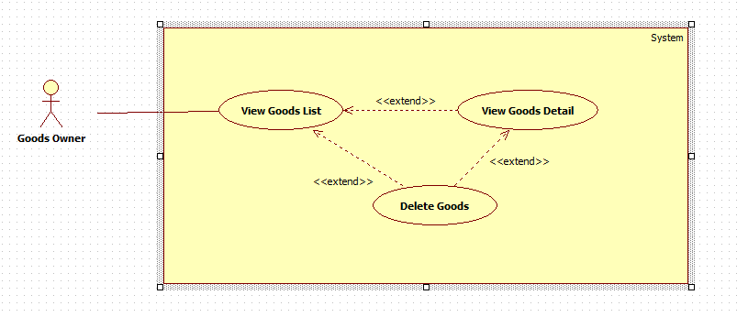

|  |  |  |  |
| --- | --- | --- | --- |
| **USE CASE – CPS001** | | | |
| **Use Case No.** |  | **Use Case Version** | 2.0 |
| **Use Case Name** | Delete Goods | | |
| **Author** | ThinhDP | | |
| **Date** |  | **Priority** | High |
| **Actor:** Goods owner  **Summary:** This use case allows goods owner to delete goods.  **Goal:** Goods will be removed from the system.  **Triggers:** Goods owner click “Xóa hàng” button in goods information page  **Preconditions:**   * User must log in to the system with role goods owners. * Goods exists in the system. * Goods is not in deal with any drivers.   **Post Conditions:**   * **Success:** Goods will be deleted from database * **Fail:** Goods is not deleted. Error message will be shown   **Main Success Scenario:**   |  |  |  | | --- | --- | --- | | Step | Actor Action | System Respone | | 1 | Goods owner click on a goods in “Hàng hóa” tab, then swipe to “Thông tin” tab. Goods owner clicks “Xóa hàng” button. | System shows comfirm pop-up: “Bạn có muốn xóa hàng không?”   * Đồng ý: button * Hủy: button | | 2 | Click on “Đồng ý” button.  [Exception 1] | Goods from database |   **Alternative Scenario:**   |  |  |  | | --- | --- | --- | | No | Actor Action | System Response | | 1 | Click on “Hủy” button | Pop-up is turn-off. Goods is not deleted |   **Exceptions:**   |  |  |  | | --- | --- | --- | | No | Actor Action | System Response | | 1 | Click on “Đồng ý” button | Goods is not deleted. Show error message: “Chức năng hiện đang bị lỗi. Xin thử lại sau” |   **Relationships:** extended by View Goods List, extended by View Goods Detail  **Business Rules:**   * Goods must exist in database. * When goods status is “2”, owner will not be able to press “Xóa” button. * Goods status is changed to “0” | | | |

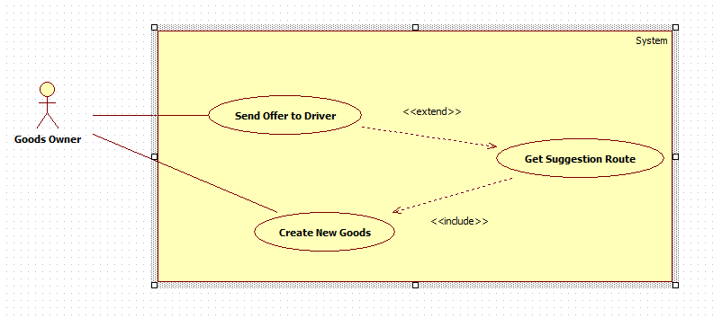

|  |  |  |  |
| --- | --- | --- | --- |
| **USE CASE – CPS001** | | | |
| **Use Case No.** |  | **Use Case Version** | 2.0 |
| **Use Case Name** | Send offer to driver | | |
| **Author** | ThinhDP | | |
| **Date** |  | **Priority** | High |
| **Actor:** Goods owner  **Summary:** This use case allows goods owner to send new deal to truck driver.  **Goal:** To start a new deal with truck driver.  **Triggers:** Goods owner clicks “Đề nghị” button in truck driver’s information page.  **Preconditions:**   * User must log in to the system with role goods owners. * Goods and route is active. * You are not dealing about specific goods with truck driver.   **Post Conditions:**   * **Success:** New deal is sent to truck driver. Success message is shown * **Fail:** Error message is shown   **Main Success Scenario:**   |  |  |  | | --- | --- | --- | | Step | Actor Action | System Respone | | 1 | In driver suggestion page, owner click on a driver he wants to deal | System navigates to dealing’s information page. | | 2 | Owner clicks on “Đề nghị” button  [Alternative 1] | A new deal is sent to truck driver. Success message is shown: “Đề nghị đã được gửi”  [Exception 1] |   **Alternative Scenario:**   |  |  |  | | --- | --- | --- | | No | Actor Action | System Response | | 1 | Goods owner click “Hủy” button | System returns to previous page. No deal is sent. |   **Exceptions:**   |  |  |  | | --- | --- | --- | | No | Actor Action | System Response | | 1 | Owner clicks on “Đề nghị giao dịch” button | New deal is not sent. Show error message: “Đề nghị đã không được gửi. Xin thử lại sau” |   **Relationships:** extended by View Suggestion Route  **Business Rules:**   * Goods owner can send deal to as many driver as he wants. * System must make sure both goods and route are available before offer is sent. If route is not available, system will notify owner. * New offer is saved to database with pending state. If offer is sent, system will notify driver about new deal. If notification is failed to send, system will resent it one more time. If notification is failed to send twice, driver will be removed from suggestion list. | | | |

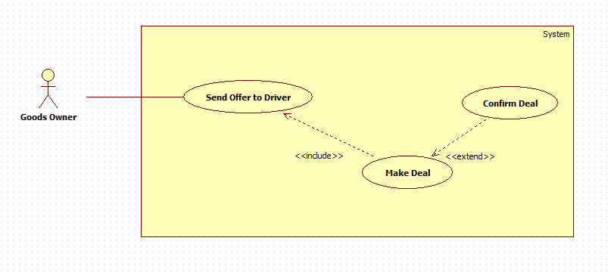

|  |  |  |  |
| --- | --- | --- | --- |
| **USE CASE – CPS001** | | | |
| **Use Case No.** |  | **Use Case Version** | 2.0 |
| **Use Case Name** | Confirm deal | | |
| **Author** | ThinhDP | | |
| **Date** |  | **Priority** | High |
| **Actor:** Goods owner  **Summary:** This use case allows goods owner to accept or decline a deal sent from truck driver.  **Goal:** The deal will be accepted or declined by owner.  **Triggers:** Goods owner click “Chấp nhận” or “Từ chối” button.  **Preconditions:**   * Goods owner must log in to the system with role goods owners. * The deal still exists.   **Post Conditions:**   * **Success:** The deal sent from truck driver is accepted * **Fail:** Deal is not accepted. Error message is shown   **Main Success Scenario:**   |  |  |  | | --- | --- | --- | | Step | Actor Action | System Respone | | 1 | Goods owner clicks “Chấp nhận” button.  [Alternative 1] | Deal is accepted. Message is shown: “Đề nghị đã được chấp nhận”.  [Exception 1] |   **Alternative Scenario:**   |  |  |  | | --- | --- | --- | | No | Actor Action | System Response | | 1 | Goods owner clicks “Từ chối” button. | Deal is declined. Message is shown: “Đề nghị đã được từ chối”.  [Exception 2] |   **Exceptions:**   |  |  |  | | --- | --- | --- | | No | Actor Action | System Response | | 1 | Goods owner click “Chấp nhận” button. | Deal is still not accepted. Error message is shown: “Đề nghị vẫn chưa được chấp nhận. Xin thử lại sau”. | | 2 | Goods owner clicks “Từ chối” button. | Deal is still not declined. Error message is shown: “Đề nghị vẫn chưa được từ chối. Xin thử lại sau” |   **Relationships:** extended by Make Deal  **Business Rules:**   * When deal is accepted, system will change status to accepted, deal will be added to Order table. * When deal is declined, system will changed status to declined. * When deal is accepted or decline, success message will be shown. When error happens, error message will be shown. * System owner accepts deal, system will check if deal is cancelled or not. If yes, error message will be shown to owner. * System will notify driver when deal is accepted or declined. | | | |

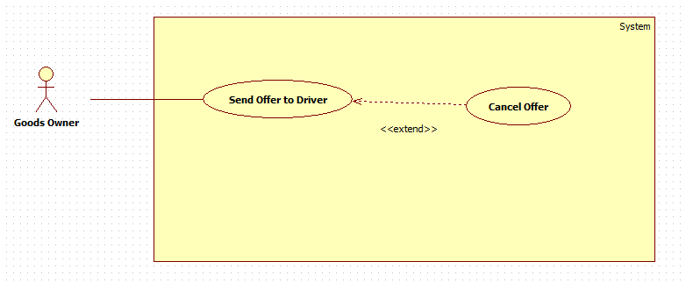

|  |  |  |  |
| --- | --- | --- | --- |
| **USE CASE – CPS001** | | | |
| **Use Case No.** |  | **Use Case Version** | 2.0 |
| **Use Case Name** | Cancel Offer | | |
| **Author** | ThinhDP | | |
| **Date** |  | **Priority** | High |
| **Actor:** Goods owner  **Summary:** This use case allows goods owner to cancel the deal he sent to driver.  **Goal:** The deal will be cancel.  **Triggers:** Goods owner click “Hủy đề nghị” in deal information page.  **Preconditions:**   * Goods owner must log in to the system with role goods owners. * Driver hasn’t accepted the deal yet.   **Post Conditions:**   * **Success:** A deal sent by owner will be cancel * **Fail:** Deal is not cancel. Error message is shown   **Main Success Scenario:**   |  |  |  | | --- | --- | --- | | Step | Actor Action | System Respone | | 1 | Goods owner clicks “Hủy đề nghị” button. | System show confirmation message: “Bạn có muốn hủy đề nghị không?” | | 2 | Goods owner clicks “Có” button  [Alternative 1] | Offer is cancelled. Success message is shown: “Bạn đã hủy đề nghị thành công.”  [Exception 1] |   **Alternative Scenario:**   |  |  |  | | --- | --- | --- | | No | Actor Action | System Respone | | 1 | Goods owner clicks “Không” button. | Offer is not cancelled. |   **Exceptions:**   |  |  |  | | --- | --- | --- | | No | Actor Action | System Response | | 1 | Goods owner click “Hủy đề nghị” button | Deal is still not accepted. Error message is shown: “Đề nghị vẫn chưa được hủy. Xin thử lại sau” |   **Relationships:** extended by Send Offer To Driver  **Business Rules:**   * System can only cancel deal when it’s not accepted by driver yet. If deal is already accepted, error message will be shown to owner. * When deal is cancel, it will be removed from “Giao dịch” tab * When deal is cancel, driver will be notified about it. * Offer is marked as cancelled in database. | | | |

|  |  |  |  |
| --- | --- | --- | --- |
| **USE CASE – CPS001** | | | |
| **Use Case No.** |  | **Use Case Version** | 2.0 |
| **Use Case Name** | Tracking delivery information – Track status | | |
| **Author** | ThinhDP | | |
| **Date** |  | **Priority** | High |
| **Actor:** Goods owner  **Summary:** This use case allows goods owner to track delivery status.  **Goal:** To know the current status of goods delivery.  **Triggers:** Goods owner clicks on “Trạng thái hàng” tab  **Preconditions:**   * Goods owner must log in to the system with role goods owners. * Goods is accepted between driver and owner.   **Post Conditions:**   * **Success:** Satus of the goods is shown next to goods id * **Fail:** Status is not shown. Error message is shown   **Main Success Scenario:**   |  |  |  | | --- | --- | --- | | Step | Actor Action | System Respone | | 1 | Goods owner clicks “Trạng thái hàng” tab  [Exception 1,2] | System navigates to tracking page. System shows list of goods with current status |   **Alternative Scenario:** N/A  **Exceptions:**   |  |  |  | | --- | --- | --- | | No | Actor Action | System Response | | 1 | Goods owner clicks “Trạng thái hàng” tab | Status is not shown. Show error message: “Không thể tải trạng thái của hàng. Xin thử lại sau.” | | 2 | Goods owner clicks “Trạng thái hàng” tab | No goods are shown. Show error message: “Không thể tải danh sách hàng. Xin thử lại sau” |   **Relationships:** Tracking delivery information  **Business Rules:**   * Goods is accepted between driver and owner. * Status are: “Hàng đang giao, hàng đã gửi” | | | |